Term Project:
The Triathlete’s Training Program
Xavier Torres
CSCI E-10b
David Habermehl
December 13, 2024

Abstract
The Triathlete’s Training Program is a developed proof of concept currently using Java version 22. The program’s intent is to assist a triathlete to improve athletic performance and predict a triathlon race outcome on the events of swimming, cycling, and running. The program will accomplish this using a custom developed scientific algorithm. The triathlete will store their personal information to include name, age, weight, and height. The triathlete will also input details about individual training sessions to include time, distance, and speed. The program will use the custom developed scientific algorithm and prediction logic to compare past events based on the data analyzed. Overall, the program will provide a predictive race outcome to assist them on preparing for race day and meet their triathlon race goals.

Introduction
The Triathlete’s Training program is an object-oriented program based on Java version 22. The program consists of various Java classes and methods designed to enable a triathlete to upload data that will assist during the training season in preparation for a race event. The information will be manually inputted or uploaded in an excel spreadsheet. The data consist of the event type, the distance, time and speed for each training session completed. The program is designed to analyze the data that is uploaded or manually added. Once the triathlete applies the respective data and clicks to perform analysis, the custom developed scientific algorithm will analyze the data and output the predictive race outcome.
Purpose of The Triathlete Training Program
The program’s purpose will be to assist the triathlete during the training season and output improvements based on compared training sessions with overall intent of predicting race outcome. The intent of the program is for the triathlete to utilize during overall training season to assist in fulfilling race outcome goals. The type of triathlon races the program predicts by default is a typical 70.3 Iron Man Triathlon, which consist of the following consecutive events:
- 1.2 miles of swimming.
- 56 miles of cycling.
- 13.1 miles of running.
The Program’s High Level Flow Chart
The program begins with the main method as the main entry point in the ‘TriathleteTrainingProgram.java’ file. The ‘Triathlete.java’ file provides the fields necessary to store the triathlete’s information. Once the program is compiled and executed, a window will display to the user with various buttons.
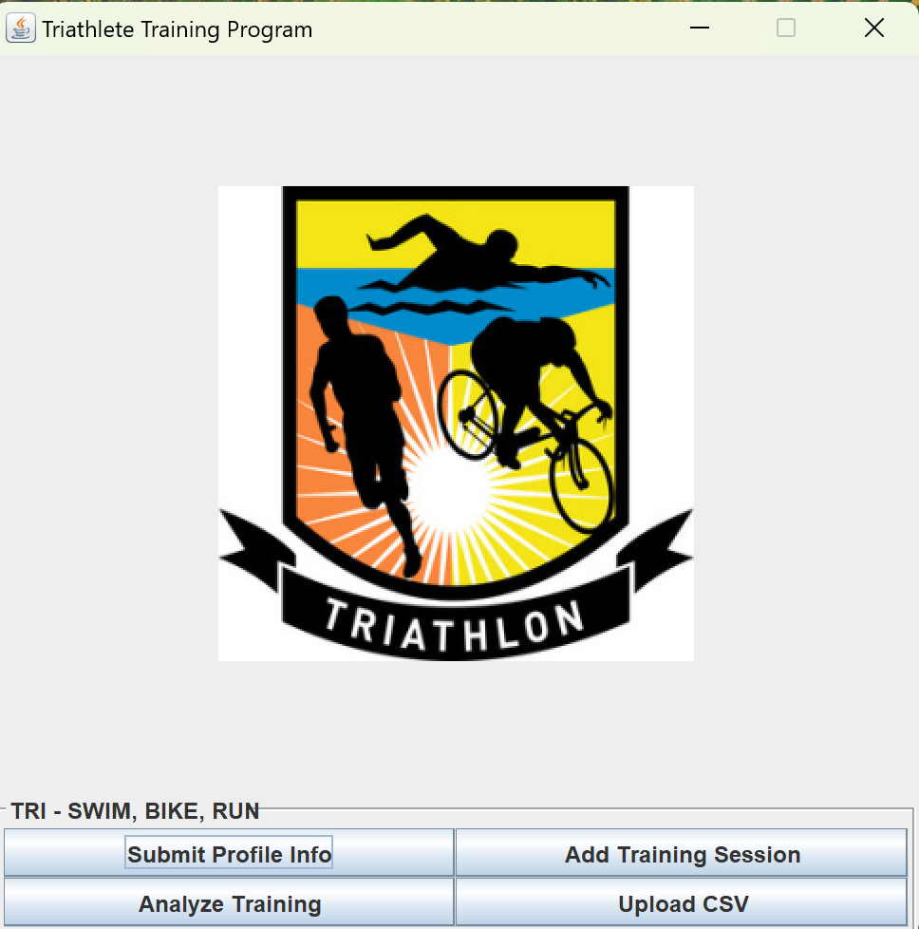
The window display prompts that the triathlete receives are done in graphical user interface (GUI) widgets comprised of window boxes, text fields, and buttons. The information stored comprises of the following:
- Triathletes’ information such as age, height, weight.
- Triathlete’s training sessions completed for each event in swim, bike, and run to include distance, speed, and time completed for each.
The program takes the information and performs a training analysis based on algorithms to provide a predictive race day outcome for a half-ironman triathlon event to include the overall race time to completion. The prediction will be based on the factors of the total times from the past training sessions and the triathlete’s age, weight, height and used within the algorithm to provide the output of the predictive race time.

Figure 1: Diagram of Triathlete Program.

The Classes and Methods
As described in ‘Figure 1: Diagram of Triathlete Program’, the following classes and methods will be used in addition to helper methods as required.
- The Triathlete Training Program class. This is the class that holds the main method, where the program begins execution. The class also leverages the required methods and inner class for the build layout of the GUI.
- The Triathlete class. The class that will store the field variables to include age, height and weight. The class will have the Constructors, getters and setters, to be utilized by the other respective classes within the program.
- The Training Session class. The class that will store the field variables for the data respective completed events, time, distance and speed of the Triathlete. The class will also have Constructors, getters, and setters.
- The Training Analysis class. The class that will have the methods to perform analysis for the predictive race outcome. This is the class that performs the core operations of the program, to include analyzing the data and utilizing the custom developed scientific algorithm to predict the overall race outcome. In addition, the algorithm makes adjustments based on the factors that can influence performance to include age, height, and weight. Overall, the algorithm provides a near realistic prediction of the overall race time a triathlete would achieve based on the data provided.
How to Compile and Run the Program
Pre-requisites
- The Triathlete Training Program requires Java version 22 to compile and run. The user can utilize their preferred code editor of choice, such as VS Code, Visual Studio, or Eclipse. Ensure these are installed and running prior to compiling and running the program.
- The file ‘termProject’ must be downloaded and extracted to your local computer path.

- The triathlete’s personal information is manually added using the ‘submit profile info’ button. There are two options to add the data for training sessions, by using ‘add training session’ or by ‘upload csv’.
  - Add training session. Should you choose to add the training sessions, you will need to manually add each event type and the distance time and speed for each.
  - Upload CSV. Should you choose to utilize a spreadsheet to record the data, the folder contains an excel spreadsheet titled ‘training sessions.csv’. The spreadsheet provides sample data as shown in the diagram below.

Note: The allowed values for event type are swim, bike, or run. The value for distance must be measured in miles. The value for time is measured in minutes. The value for speed is measured in kilometers and must be set as a double.

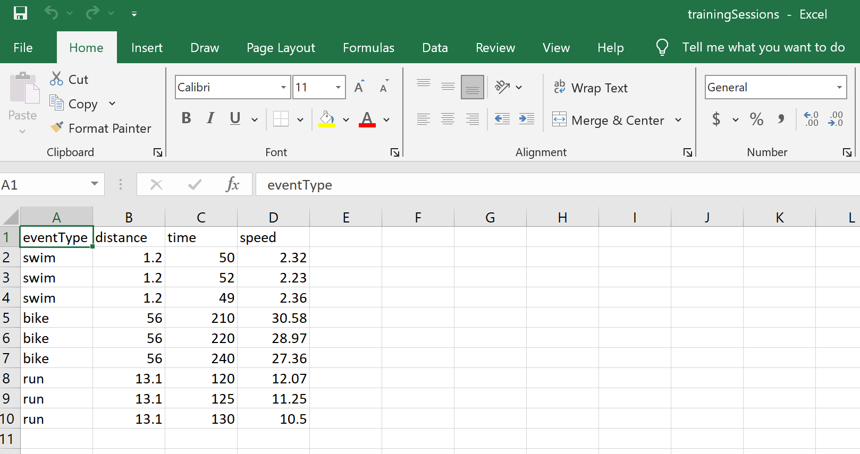
Figure 2: training session spreadsheet.
The Procedures
The following procedures must be followed for the program to compile and run successfully:
- Download the zip file ‘termProject’ and extract the file to a specified location on your local computer. Keep note of the specified location path of the file.
- Open your preferred code editor of choice on your local computer. Click on the terminal to open within the code editor.
- On the terminal, enter the following to enter the content directory of the extracted file path.
    - cd <specified location path of the file>
- To validate that the term Project files are within the current directory, type the following:
    - ls
Note: you should see the following file names listed:
- TrainingAnalysis.java
- TrainingSession.java
- Triathlete.java
- TriathleteTrainingProgram.java
- Upon validating the files are listed within the current directory, type the following to compile the program:
    - javac TriathleteTrainingProgram.java
- Once the program compiles successfully, you will see the prompt to type the next command. Enter the following to run the program:
    - java TriathleteTrainingProgram
- The program will begin running and a display window will pop up as shown in the diagram below.
Figure 3: Triathlete Training Program Main Window.
Triathlete’s Development Info
- There will be four buttons on the bottom of the window. Click on ‘Submit Profile Info’.
- Another window display will appear as shown in the diagram below.

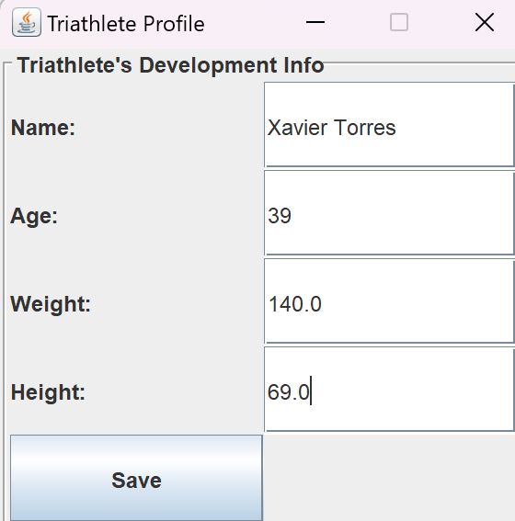
Figure 4: Triathlete Profile Sub Window.

- Enter the following on the text boxes located on the right:
    - Name: <the triathlete’s name> (example: Xavier Torres)
    - Age: <the triathlete’s age> (example: 39)
    - Weight: <the triathlete’s weight in double format> (example: 140.0)
    - Height: <the triathlete’s height in inches and in double format> (example: 69.0)
- Click Save. A message prompt will display confirming that the information has been saved. Click Ok.

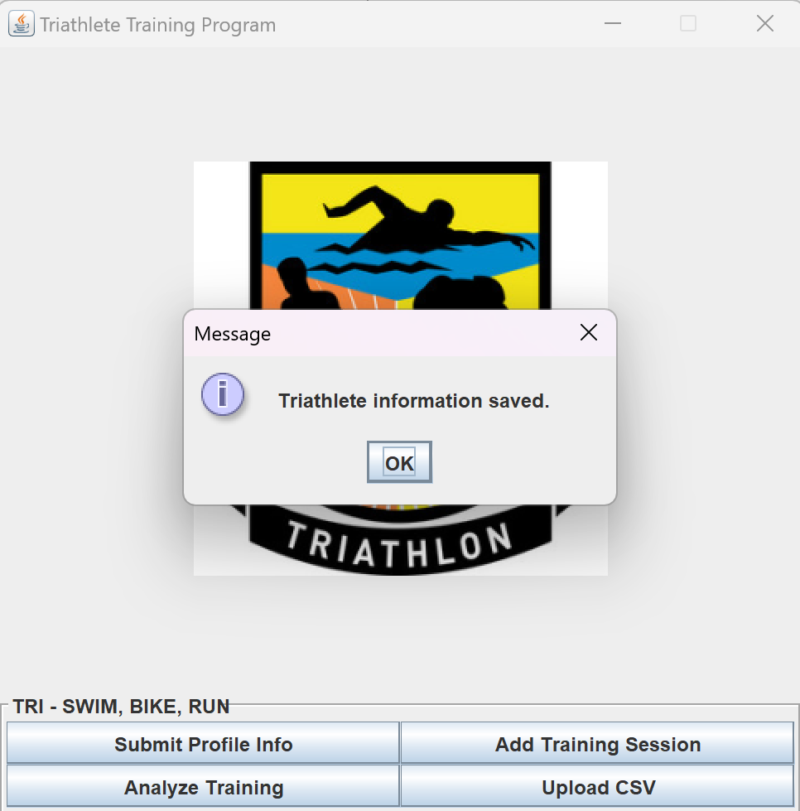
Figure 5: Triathlete Profile Message Prompt.

- Close out the ‘Triathlete’s Development Info’ window display by clicking the X at the top right corner.
Training Sessions
To record training sessions using excel spreadsheet, follow option 1 procedures. To manually record each training session, follow option 2 procedures.
Note: Should you choose to utilize the spreadsheet to add the training sessions, ensure to add the past event data as shown in the sample file. The distance must be recorded in miles. The time must be recorded in minutes. The speed must be recorded in kilometers per hour.
Option 1: Upload CSV.
- Click on Upload CSV.
- The term project folder contains an excel spreadsheet titled ‘Training Sessions.csv’. Locate the term project folder that was previously extracted on your local computer path and click open.
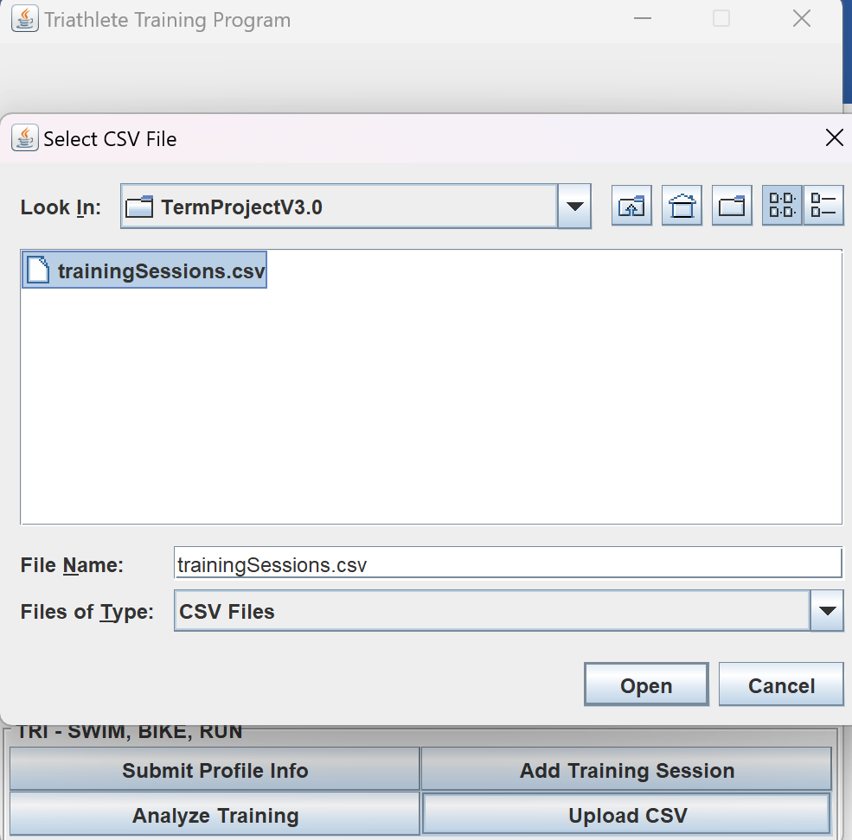
Figure 6: Upload CSV Sub Window.
- Click Open. A window prompt will display confirming the .csv file has imported successfully.
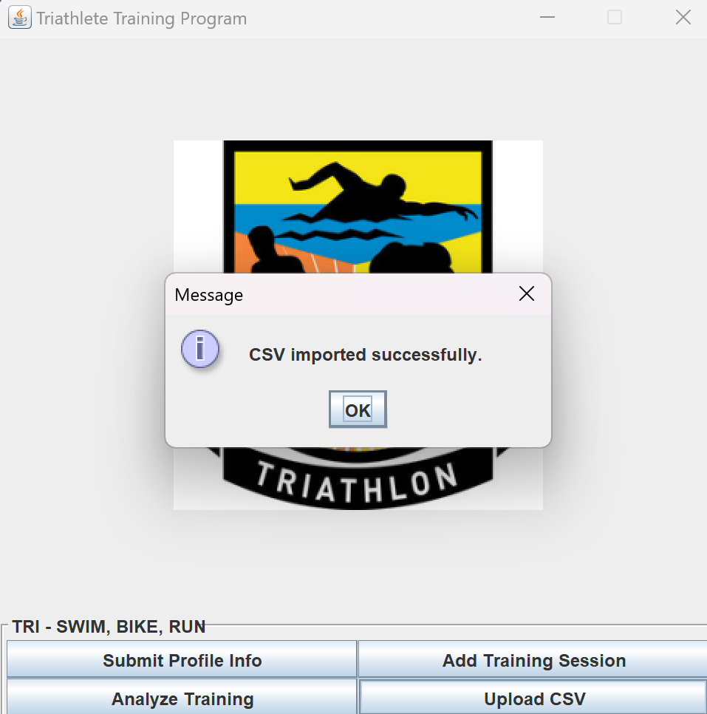
Figure 7: Upload CSV Message Prompt.

Option 2: Add Training Sessions
- Click on ‘add training session’.
- Add the following:
    - Event type: <the training session completed> (example: swim)
    - Distance: <the miles completed> (example: 1.2)
    - Time: <the time completed in double value> (example: 50.00)
    - Speed: <the average kilometers per hour> (example: 2.32)

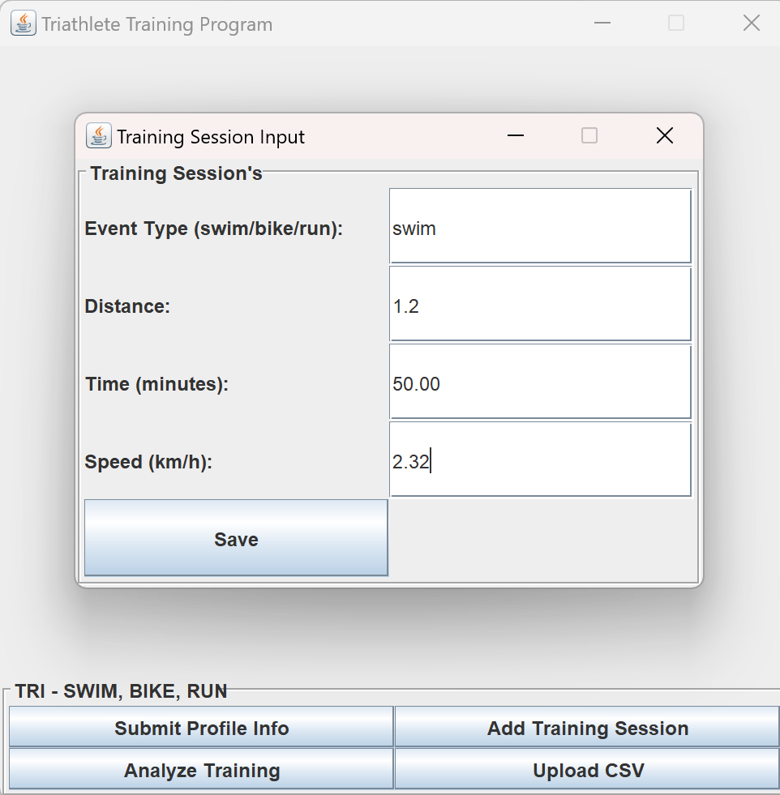
Figure 8: Add Training Session Sub Window.
- Click on save.
- Should there be more training sessions to add, repeat steps 17 – 18.
Analyze Training
- Click on Analyze Training.
The training analysis based on the data imported will perform and a prompt will display with the formatted data displayed to include the name, age, and overall race time prediction.
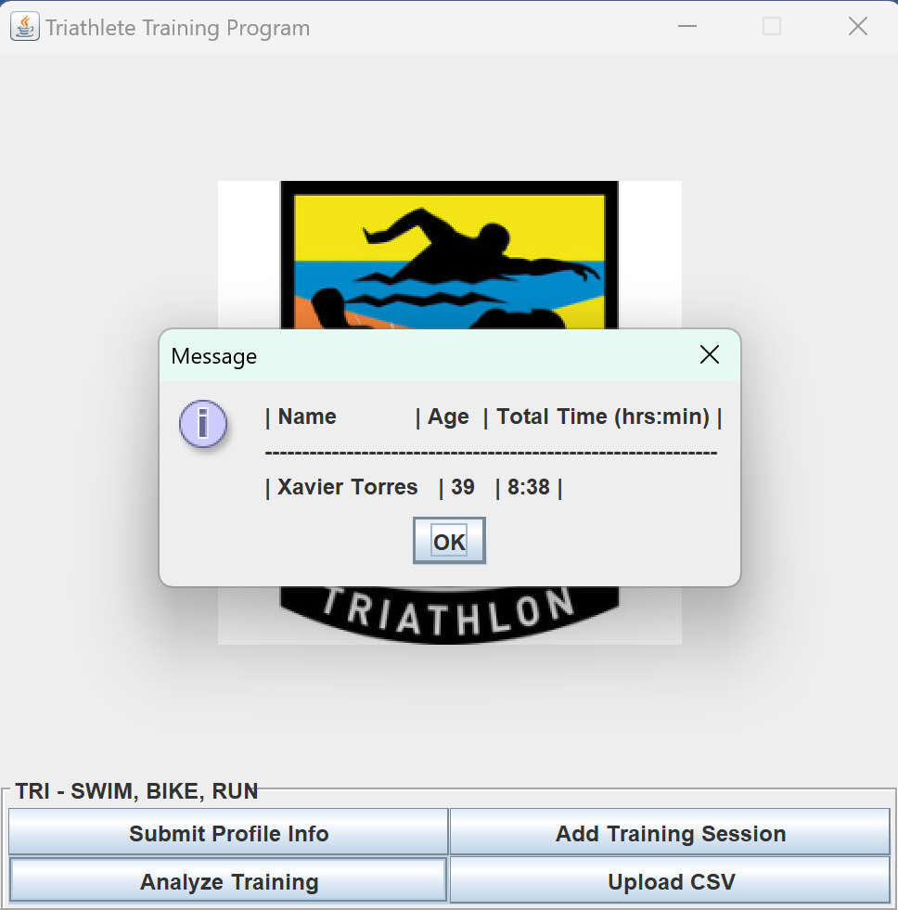
Figure 9: Analyze Training Formatted Message Prompt.
- Click ok to close the message prompt.
- Upon completion of program, click the top right corner X to exit.
Conclusion
With final remarks, the Triathlete’s Training Program has been addressed to include its purpose and intent. The flow chart has been described which outlines the programs classes and methods from a high-level overview. How the program can be used has also been provided to include the step-by-step procedures. Overall, the program will provide useful assistance to a triathlete preparing for a triathlon race during their training season to strive for improvements and reach their race day goals.

References

Oracle. (2024, 10 23). Components class. Retrieved from Java Platform Standard Edition (SE): https://docs.oracle.com/javase/8/docs/api/
Oracle. (2024, 10 23). Interface Swing Constants. Retrieved from Java Platform Standard Edition (SE): https://docs.oracle.com/javase/8/docs/api/
Stepp, S. R. (2019). Building Java Programs 5th Ed. Hoboken, New Jersey: Pearson Education, Inc.

